Combining UAV remote sensing data to estimate daily-scale crop water stress index: Enhancing diagnostic temporal representativeness
Abstract
Using thermal infrared remote sensing from unmanned aerial vehicles (UAVs) to obtain crop canopy temperature and calculate the crop water stress index (CWSI) is a promising method for monitoring field water conditions. However, such endeavors are often constrained to instantaneous scales due to the diurnal variability of thermal infrared data. To address this limitation, we developed a daily-scale CWSI suitable for UAV remote sensing, enhancing the temporal representativeness of crop water stress diagnostics. We focused on spring maize in the Hetao Irrigation District of Inner Mongolia and investigated four key growth stages. UAV thermal infrared was used to obtain multiple instantaneous statistical CWSI (CWSI_{s}) values during the day. UAV multispectral data and the Penman–Monteith model were combined to obtain the actual evapotranspiration and daily-scale CWSI (CWSI_{t_day}). A temporal upscaling model from instantaneous CSWI to daily-scale CWSI was established by comparing the relationships between the CWSI_{s} and CWSI_{t_day} at different times. Results show that compared to the fluctuations of the CWSI_{s} values throughout the day, those of the CWSI_{t_day} values were smaller, with values of 0.13, 0.09, 0.03, and 0.03 during the ninth leaf (V9), tasseling (VT), silking (R1), and milk (R3) stages, respectively. The CWSI_{t_day} demonstrated a higher correlation with the measured stomatal conductance (𝑔𝑠) at different time periods, thereby being more stable and temporally representative. However, both indices may incorrectly interpret the decline in leaf physiological activity due to aging as water stress at the end of maize growth, leading to overestimated CWSI values. The temporal upscaling model, which was developed by combining CWSI_{s} values observed at 12:00, 14:00, and 16:00 with the random forest regression algorithm, achieved coefficient of determination of 0.794 and root mean square error of 0.04. Hence, multiple instantaneous observations can be used effectively instead of daily-scale observations, providing key insights into the popularization and application of the CWSI_{t_day}. Overall, this study presents a new method for obtaining continuous CWSI values with high temporal and spatial resolutions based on a UAV platform.
Graphical Abstract
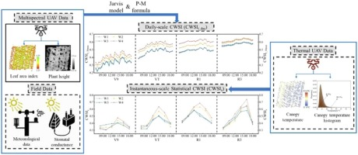
Keywords
UAVCrop water stress indexDaily-scale temporal upscalingStomatal conductance
1. Introduction
Crop water stress is widespread across various agricultural environments. Crop drought negatively affects crop growth and development, leading to decreased crop yield (Seleiman et al., 2021). Currently, the primary indicators used for assessing crop water stress include soil moisture, crop stem/leaf water potential, stomatal conductance (𝑔𝑠), and transpiration rate (Anjum et al., 2011). However, collecting these indicators is time- and labor-intensive, involving mostly point-scale measurements, which cannot effectively represent the spatial variability of crop water status. Therefore, such endeavors are not suitable for conducting large-scale field water monitoring. The rapid development of remote sensing technology—particularly unmanned aerial vehicle (UAV) remote sensing—has accentuated the associated advantages, such as low cost, short measurement cycles, and flexible operation, thereby enabling monitoring and research applications across various fields (Wang et al., 2024). In particular, precision agriculture monitoring has become possible, as UAVs equipped with different types of sensors can swiftly capture crop images with high spatial and temporal resolutions. In this respect, this study provides a detailed understanding of real-time crop water conditions (Elsherbiny et al., 2021) and offers new technological methods for field crop drought monitoring.
Currently, the most popular method for monitoring crop water stress using UAV remote sensing platforms utilizes the crop water stress index (CWSI) to assess crop water deficit conditions. The CWSI was initially proposed by Idso et al. (1981) and primarily relies on the principle of the inverse relationship among canopy temperature (T_{c}), leaf transpiration, and 𝑔𝑠. Specifically, when water supply is sufficient, plant stomata open, allowing transpiration to occur, which cools the surrounding air, resulting in a T_{c} decrease. Conversely, when plants experience water stress, stomatal conductance decreases, reducing the transpiration rate and, consequently, diminishing the cooling effect. Hence, the CWSI is widely recognized as an appropriate indicator of plant water status.
CWSI calculation methods based on UAV platforms are categorized into three main types regarding the different solutions determining the non-water-stressed conditions (lower baseline) and non-transpiring conditions (upper baseline). The first method involves a theoretical CWSI (CWSI_{t}) that derives the lower and upper baselines from the crop canopy energy balance equation (Jackson et al., 1981). However, the parameters involved in the calculation, namely aerodynamic resistance (r_{a}) and canopy resistance (r_{c}), are extremely complex, with the reliability of the CWSI_{t} being largely dependent on their values, leading to possible misdiagnoses regarding whether crops are subjected to water stress (Agam et al., 2013). The second method involves an empirical CWSI (CWSI_{e}) obtained by combining the empirical relationship between the canopy–air temperature difference and saturated water vapor pressure difference (VPD) to establish the upper and lower baselines (Idso et al., 1981). Some studies have also used the measured canopy temperature in water-stressed and adequately irrigated crops as the upper and lower baselines, respectively (Park et al., 2021). Artificial reference surfaces have also been substituted for temperature measurements in both cases (Santesteban et al., 2017). However, the upper and lower baselines of the CWSI_{e} need to be determined appropriately according to different climatic conditions (Gonzalez-Dugo et al., 2014) and crop scenarios for which empirical methods can be applied. Some studies adopt a method involving a statistical CWSI (CWSI_{s}). This method defines non-transpiring temperature (T_{dry}) and non-water-stressed temperature (T_{wet}) using specific quantiles in histograms of remote sensing thermal infrared images and then calculates the CWSI_{s} (Bian et al., 2019, Park et al., 2017, Wang et al., 2024). Hence, the CWSI_{s} does not rely on meteorological parameters and ground references, thereby substantially reducing computational complexity. Prior research involving the use of UAV remote sensing platforms to calculate the CWSI and diagnose crop water stress has shown better results in specific environments and at specific times. However, the strong time variability of thermal infrared data collected by UAVs that occurs under changing climatic conditions is an inherent limitation, leading to strong fluctuations in the instantaneous CWSI. Hence, determining how to obtain a more time-representative CWSI is a worthwhile research direction.
Daily-scale data can better capture the diurnal physiological dynamics of plants by aggregating information over the duration of an entire day (Lee and Im, 2024). Compared to instantaneous-scale data, daily-scale data effectively reduce short-term fluctuations caused by daytime climate change and provide a more representative depiction of the entire day. This facilitates comparisons and analyses across different crop growth stages, enabling better identification of long-term trends and cyclical variations of crop water stress. Therefore, the daily-scale CWSI is effective for improving the temporal representativeness of crop water stress. Currently, the daily-scale CWSI is mostly calculated using the definition of the CWSI_{t}, i.e., 1 minus the ratio of actual crop evapotranspiration (ET_{c act}) to potential crop evapotranspiration (ET_{p}) (Jackson et al., 1981).However, ET_{c act} is often measured using equipment such as eddy covariance systems, whereas ET_{p} is mostly estimated using models (Liu et al., 2023, Tong et al., 2019). Alternatively, ground-fixed thermal infrared sensors can be deployed for conducting continuous high-frequency monitoring of canopy temperatures and obtaining a daily-scale CWSI (Agam et al., 2013). This method enables continuous and accurate monitoring of plant water status. However, expensive equipment, frequent maintenance, and limited monitoring ranges limit its application to the scientific research level. Contrary to ground equipment, UAVs are limited by battery life and cannot make continuous and uninterrupted observations. To overcome this shortcoming, some studies zoomed in on daily “one-shot” images acquired using UAV systems and used the instantaneous CWSI at a certain time point as a criterion for determining crop water stress (Bian et al., 2019, Park et al., 2017, Santesteban et al., 2017). However, differences in the time of day and instantaneous meteorological conditions can lead to different results. The optimal time of day for observing the CWSI has also been investigated using instantaneous observations to indicate the daily crop water stress (Bellvert et al., 2014, Liu et al., 2023, Liu et al., 2020, Park et al., 2021). Midday and early afternoon (12:00–15:00) are typically regarded as the most suitable times for obtaining canopy–air temperature difference data to assess plant water stress. However, such a procedure tends to be under-representative, because it only captures the instantaneous moment of a crop’s condition and does not provide a full assessment of its exposure to water stress. Osroosh et al. (2016) demonstrated that the daily (i.e., 07:00–19:00) average CWSI can be used for more reliable monitoring of water stress in fruit trees, mitigating short-term microclimatic effects and time interval influences and offering a more stable index for irrigation scheduling. Therefore, combining the advantages of multispectral and thermal data provided by UAV platforms to find a CWSI that can be recorded continuously with high temporal and spatial resolutions is necessary. Such a CWSI should have increased temporal representativeness without being susceptible to environmental influences, enabling more accurate assessments of crop water stress and constituting a more stable reference for irrigation scheduling.
The specific objectives of this study were as follows: (1) Propose a method for calculating a daily-scale CWSI (CWSI_{t_day}) based on UAV remote sensing platforms; (2) compare and analyze the abilities of the CWSI_{t_day} and instantaneous CWSI_{s} at different time periods to assess crop water conditions; and (3) explore the feasibility of establishing a temporal upscaling model using multiple instantaneous CWSI_{s} observations to replace the CWSI_{t_day} and propose the optimal substitution strategy.
2. Materials and methods
2.1. Study area and experimental treatments
The experiment was conducted from April to October 2023 at the Corn Science and Technology Courtyard in the Hetao Irrigation District of the Inner Mongolia Autonomous Region, China (41.0776° N, 108.0078° E; elevation: 1027.91 m above sea level) (Fig. 1). The experimental area falls within the temperate continental monsoon climate zone, with an average annual temperature of 8.42 °C and an annual precipitation of approximately 46.1 mm. The soil in the experimental area is predominantly silty loam, as determined using the soil texture triangle recommended by the United States Department of Agriculture (Shirazi et al., 1989). Before sowing, physicochemical analyses were conducted on the basal soil samples. The average soil bulk density in the 0–40-cm soil layer was 1.61 g cm⁻³. The field capacity and wilting coefficient were 0.32 and 0.09 cm³ cm⁻³, respectively. Soil organic carbon, total nitrogen, and available phosphorus were measured at 20.89 g kg⁻¹, 0.92 g kg⁻¹, and 18.21 mg kg⁻¹, respectively. The maize planting followed a wide–narrow row pattern, with wide row spacing of 0.8 m, narrow row spacing of 0.4 m, and plant spacing of 0.2 m, resulting in a planting density of approximately 67,000 plants ha⁻¹. Drip irrigation was used with the drip tape spacing set to 1.2 m.
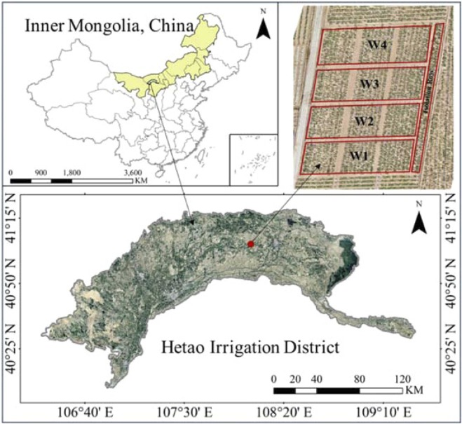
- Download: Download high-res image (574KB)
- Download: Download full-size image
Fig. 1. Location and treatments of the experiment in this study. W1, W2, W3, and W4 represent high deficit, moderate deficit, slight deficit, and local irrigation, respectively.
To align with local irrigation management practices and address local needs, the experiment included four irrigation treatments: severe water deficit (W1), moderate water deficit (W2), mild water deficit (W3), and a local standard irrigation quota of 25 mm (W4). Treatments W1, W2, and W3 were set to 40 %, 60 %, and 80 % of the W4 irrigation quota, corresponding to 10, 15, and 20 mm per irrigation event, respectively. Each treatment included two replicate plots, resulting in a total of 12 experimental fields, each measuring 8 × 8 m. Water distribution within each plot was independently managed using turbine flow meters, and 1.5-m separator strips were established between adjacent plots to prevent interference. Six irrigation events were conducted on May–June 23, July 10, July 1, August 16, August 9, and August 24, 2023. Prior to planting in early November 2022, each treatment received one heavy irrigation event (i.e., irrigation quota of 225 mm), mimicking local farming practices. Following heavy irrigation, the field irrigation water froze and stayed frozen until April of the following year, when irrigation water sourced from the Yellow River initiated the thaw.
The spring maize was sown on April 24 (DOY114), with the variety being ‘Ximeng3358’. Germination occurred on May 2 (DOY122) and harvesting occurred on September 28 (DOY271), resulting in a total growth period of 156 d. The treatment plots were fertilized according to local practices. Nitrogen and phosphorus fertilizers were applied at 225 and 70 kg ha⁻¹, respectively. Initially, half of the nitrogen fertilizer and all of the phosphorus fertilizer were applied simultaneously as the basal fertilizer. Of the remaining nitrogen fertilizer, half was applied with the second irrigation, and the other half was applied with the third irrigation. Four ground control points (GCPs) were established in the experimental area at the corners of the field ridges for geographic image alignment and geometric correction. Specific precipitation, irrigation, and sampling events are shown in Fig. 2.
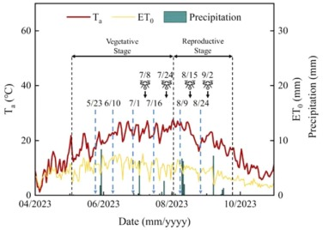
- Download: Download high-res image (136KB)
- Download: Download full-size image
Fig. 2. Daily average temperature (T_{a}), reference crop evapotranspiration (ET₀), daily precipitation, and timing of each growth stage for maize in 2023 (the red line represents T_{a}, the yellow line represents ET₀, the green bars represent daily precipitation, black arrows indicate sampling dates, and blue dashed lines indicate irrigation events).
2.2. UAV image acquisition
2.2.1. Thermal image acquisition
Images were collected using a DJI M300 Pro drone (DJI Technology Co., Ltd., Shenzhen, China), with a maximum take-off weight of 9 kg and the capability to carry a maximum payload of 2.7 kg. The drone was equipped with a Zenmuse H20T thermal camera (DJI Technology Co., Ltd., Shenzhen, China), which had a temperature measurement interval of −40 to +150 °C, a wavelength range of 8–14 μm, a thermal image resolution of 640 × 512 pixels, and a focal length of 13.55 mm. The flight altitude of the drone was set to 20 m, with the flight speed being 5 m s⁻¹. Photographs were taken at equal time intervals, resulting in a ground–sample distance (GSD) of 1.78 cm pixel⁻¹. Both the longitudinal and lateral overlap rates were set to 80 %. The acquisition times for the thermal images are listed in Table 1. Each mission involved capturing approximately 548–553 images, over a duration of 15 min.
Table 1. Duration of UAV missions and corresponding meteorological parameters.
Growth stages | Date | DOY | Time | T_{a}^{[a]}  (℃) | RH  (%) | R_{n}  (MJ·m⁻²·30 min⁻¹) | WS  (m s⁻¹)
Ninth leaf  (V9) | 07/08/2023 | 188 | 07:55–08:10 | 23.49 | 49.68 | 0.157 | 1.4
 |  |  | 09:58–10:14 | 27.57 | 45.64 | 0.454 | 0.6
 |  |  | 12:01–12:16 | 29.89 | 38.08 | 0.608 | 2.3
 |  |  | 13:58–14:12 | 31.33 | 29.90 | 0.574 | 0.6
 |  |  | 16:00–16:15 | 33.08 | 29.38 | 0.442 | 0
 |  |  | 18:01–18:17 | 33.90 | 26.63 | 0.019 | 0
Tasseling  (VT) | 07/24/2023 | 204 | 07:58–08:17 | 23.54 | 63.40 | 0.033 | 0.8
 |  |  | 10:00–10:16 | 27.65 | 46.72 | 0.435 | 0
 |  |  | 12:01–12:16 | 30.84 | 47.19 | 0.586 | 1.1
 |  |  | 14:01–14:16 | 33.85 | 40.02 | 0.605 | 0
 |  |  | 16:00–16:16 | 32.72 | 50.55 | 0.417 | 0
 |  |  | 18:00–18:15 | 32.87 | 47.15 | 0.017 | 0
Silking  (R1) | 08/15/2023 | 226 | 08:00–08:16 | 24.01 | 63.15 | 0.134 | 1
 |  |  | 10:06–10:21 | 29.88 | 51.66 | 0.389 | 0.8
 |  |  | 11:57–12:15 | 31.98 | 47.73 | 0.584 | 1.5
 |  |  | 14:03–14:19 | 33.77 | 48.17 | 0.547 | 0
 |  |  | 16:02–16:17 | 33.55 | 46.13 | 0.560 | 0
 |  |  | 17:59–18:15 | 31.13 | 49.65 | 0.022 | 1.1
Milk  (R3) | 09/02/2023 | 244 | 08:02–08:16 | 19.57 | 59.67 | 0.030 | 0.4
 |  |  | 10:00–10:15 | 24.20 | 53.48 | 0.349 | 2
 |  |  | 12:04–12:20 | 27.51 | 48.18 | 0.492 | 0.6
 |  |  | 14:00–14:15 | 30.99 | 39.06 | 0.493 | 0.5
 |  |  | 15:58–16:14 | 30.47 | 38.00 | 0.302 | 0
 |  |  | 18:01–18:17 | 28.72 | 42.95 | 0.076 | 0
Note: ^{[a]} T_{a}, air temperature (℃); RH, relative humidity (%); R_{n}, net radiation (MJ·m⁻²·30 min⁻¹); WS, wind speed (m s⁻¹).
The Zenmuse H20T infrared thermal imager captures images in the R-JPEG format; hence, temperature values are not directly represented. In this study, meteorological measurements obtained from the weather station during flight, including air temperature (T_{a}), relative humidity (RH), emissivity (ε; estimated at 0.99 for maize crops), and flight altitude, were inputted in the DJI Thermal SDK 1.4 software (https://www.dji.com/), which subsequently outputted the actual temperature (Wang et al., 2024). The image format was then batch-converted from R-JPEG to RAW format. The Python NumPy module was used to convert the RAW format to TIF format, and the piexif module was used to export position and orientation system (POS) information from the TIF files. The extracted POS information and TIF files were imported into the Pix4D 4.5 software (Pix4D S.A., Switzerland) for orthorectification and stitching. GCPs were used for optimization to ensure a ground error of less than 3 cm. Prior to each flight, a black-and-white board was placed on the ground and photographed, and its temperature was measured using a handheld infrared thermometer (Fluke 62 MAX, Fluke Co., Washington State, USA) to calibrate T_{c}.
2.2.2. RGB and multispectral image acquisition
RGB and multispectral data were acquired using a Phantom 4 multispectral (P4M) system (DJI Technology Co., Ltd., Shenzhen, China). This UAV is equipped with six 2.9-inch CMOS imaging sensors, including one color sensor for conventional RGB imaging and five monochrome sensors for multispectral imaging, i.e., Blue (B; 450 ± 16 nm), Green (G; 560 ± 16 nm), Red (R; 650 ± 16 nm), Red Edge (RE; 730 ± 16 nm), and Near-infrared (NIR; 840 ± 26 nm). The P4M drone is equipped with an integrated light intensity sensor that captures sunlight intensity to compensate for illumination during image capture, thereby improving the accuracy of multispectral data acquisition. P4M data collection was scheduled immediately after capturing the thermal infrared data to ensure image accuracy. The flight altitude was set to 20 m, with the flight speed being 5 m s⁻¹. Photographs were captured in the hover mode, resulting in a GSD of 1.06 cm pixel⁻¹ and 80 % overlap rates in both the longitudinal and lateral directions. The DJI Terra 3.6.8 software was used to reconstruct and stitch the images captured using the P4M drone. Photographs of a black-and-white board on the ground were added for radiometric calibration. This process yielded orthorectified MS images and Digital Surface Models (DSM) of the experimental field. GCPs were incorporated to optimize accuracy, ensuring that the ground error was less than 3 cm. Each mission yielded approximately 1081–1092 images.
2.2.3. Soil background removal
The advantages of the Soil-Adjusted Vegetation Index (SAVI) in identifying the background value of farmland soil (Marino et al., 2021) were considered and combined with the Otsu algorithm to remove the background value of soil. The specific calculation process is presented in Appendix A.
2.3. Field data acquisition
2.3.1. Stomatal
2.3.1.1. conductance (𝒈𝒔)
The stomatal conductance of the crop leaves was measured after each UAV aerial photograph using the LCpro T Advanced Portable Photosynthesis System (ADC BioScientific Ltd., Hoddesdon, UK). Three representative maize leaves were randomly selected from each plot to determine the stomatal conductance near the tip 1/3 of the leaf surface. The average value was taken as the stomatal conductance of the sampling point. A total of 288 groups of measured leaf stomatal conductance data were obtained.
2.4. Soil moisture
2.4.1. content (𝜽)
Soil moisture content (in terms of volumetric moisture content) was measured using a conventional drying method. Sampling in each experimental treatment plot was conducted 5–7 d after irrigation. Three sampling points were randomly selected near the center of each plot. Soil samples were collected using a soil auger at depths of 0–20, 20–40, and 40–60 cm. The soil samples from the three sampling points at each depth were mixed. After drying in an oven at 105 °C for 8 h, the soil moisture content at each depth was measured. These values represented a set of soil moisture content samples. The volumetric soil moisture content (cm³ cm⁻³) was calculated as follows:(1)𝜃=𝜃𝑔×𝜌#where 𝜌 is soil bulk density (g cm⁻³). A total of 48 sets of measured soil moisture content data were obtained during the experiment.
2.4.2. Leaf area index (LAI) and plant height
The LAI and plant height were measured directly (Yang et al., 2023). For each treatment, three representative uniformly grown maize plants were selected. The length (L_{ij}) and maximum width (B_{ij}) of each leaf were recorded using a tape measure. The LAI was calculated using Eq. (2):(2)𝐿𝐴𝐼=0.75×𝜌×∑𝑚𝑗=1∑𝑛𝑖=1(𝐿𝑖𝑗×𝐵𝑖𝑗)𝑚#where n is the total number of leaves for the j-th plant, m is the number of plants, ρ is planting density, and 0.75 is the correction factor. A total of 48 sets of measured LAI data were obtained from the experiment. Regarding plant height measurements, for each treatment, one maize plant was selected, and its height was recorded using a tape measure. The latitude and longitude of the measured plants were recorded to calibrate the plant height data obtained from the UAV.
2.4.3. Meteorological data
A fully automatic weather station located 200 m away from the experimental area on a grassland reference surface recorded rainfall, air temperature (T_{a}), RH, net solar radiation (R_{n}), solar radiation, and wind speed (𝜇). The weather station was positioned 2 m above the reference ground level, with data recorded at 30-min intervals. The meteorological conditions on the sampling days were statistically calculated and are shown in Fig. 3.
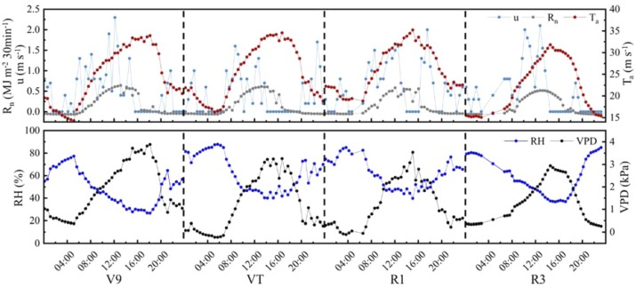
- Download: Download high-res image (314KB)
- Download: Download full-size image
Fig. 3. Meteorological data on the day of sampling. u is the wind speed at a height of 2 m, R_{n} is the net radiation, T_{a} is the air temperature, RH is the relative humidity, and VPD is the saturated water vapor pressure difference. V9, VT, R1, and R3 are the Ninth leaf stage, Tasseling stage, Silking stage, and Milk stage of maize, respectively.
2.5. Calculations
2.5.1. CWSI calculation
The calculation method for the CWSI_{s} originates from Fuchs (1990), who reported a direct correlation between leaf temperature variation and crop water stress. The formula is as follows:(3)𝐶𝑊𝑆𝐼𝑠=𝑇𝑐−𝑇𝑤𝑒𝑡𝑇𝑑𝑟𝑦−𝑇𝑤𝑒𝑡#where T_{c} is the average canopy temperature (℃) of each treatment, and T_{wet} and T_{dry} correspond to the canopy temperatures when maize plants transpire at maximum rate and when there is no transpiration at all, respectively. Frequency histograms of the canopy temperature for each treatment were generated using the ROI Compute Statistics function in ENVI 5.6. The 0.5 % and 99.5 % temperatures in the histogram were taken as T_{wet} and T_{dry}, respectively (Bian et al., 2019, Wang et al., 2024). Specific canopy temperature frequency histograms are presented in Appendix A.
The daily CWSI was calculated based on the definition of the theoretical CWSI (Jackson et al., 1981). The calculation is as follows:(4)𝐶𝑊𝑆𝐼𝑡_30⁢min=1−𝐸𝑇𝑐⁢𝑎𝑐𝑡_30⁢min𝐸𝑇𝑝_30⁢min#(5)𝐶𝑊𝑆𝐼𝑡_𝑑𝑎𝑦=1−𝐸𝑇𝑐⁢𝑎𝑐𝑡𝐸𝑇𝑝#where CWSI_{t_30min} is the 30-min CWSI, and ET_{c act_30min} and ET_{p_30min} are the 30-min cumulative actual and potential crop evapotranspiration, respectively. The CWSI is dimensionless, with values ranging between zero and one (i.e., no water stress and the most severe water stress, respectively).
ET_{c act_30min} represents the actual evapotranspiration (mm 30 min⁻¹), ET_{p_30min} represents the potential evapotranspiration (mm 30 min⁻¹), and their calculations are primarily based on the Penman–Monteith (P–M) method. ET_{c act} (mm day⁻¹) and ET_{p} (mm day⁻¹) were obtained by summing the moments when R_{n} ≥ 0 (i.e., daytime conditions). The calculation formulas are as follows (Allen et al., 1998):(6)𝐸𝑇𝑐⁢𝑎𝑐𝑡_30⁢min=Δ⁢(𝑅𝑛−𝐺)+𝜌⁢𝐶𝑝⁢𝑉𝑃𝐷𝑟𝑎Δ+𝛾⁢(1+𝑟𝑐𝑟𝑎)#(7)𝐸𝑇𝑝_30⁢min=Δ⁢(𝑅𝑛−𝐺)+𝜌⁢𝐶𝑝⁢𝑉𝑃𝐷𝑟𝑎Δ+𝛾⁢(1+𝑟𝑐𝑝𝑟𝑎)#(8)𝐸𝑇𝑐⁢𝑎𝑐𝑡=∑𝐸𝑇𝑐⁢𝑎𝑐𝑡_𝑖#(9)𝐸𝑇𝑝=∑𝐸𝑇𝑝_𝑖#where R_{n} is the net radiation (MJ m⁻² day⁻¹), G is the soil heat flux (MJ m⁻² day⁻¹; in this study: 10 % R_{n}), r_{a} is the aerodynamic resistance (s m⁻¹), r_{c} is the canopy resistance (s m⁻¹), r_{cp} is the potential canopy resistance during potential evapotranspiration (s m⁻¹), 𝛾 is the psychrometric constant (kPa ℃⁻¹), 𝜌 is the air density (kg m⁻³), VPD is the vapor pressure deficit (kPa), Δ is the slope of the saturation vapor pressuretemperature relationship (kPa ℃⁻¹), 𝐶𝑝is the heat capacity of air (in this study: 1.013 MJ kg⁻¹ ℃⁻¹), ET_{c act_i} is the i-th 30-min ET_{c act} of a day, and ET_{p_i} is the i-th 30-min ET_{p} of a day.
The 𝜌 can be determined as follows (Zhang, 2021):(10)𝜌=1.2837−0.039⁢𝑇𝑎#where T_{a} is the air temperature (°C). 𝛾 is determined as follows (Allen et al., 1998):(11)𝛾=0.665×101.3⁢(293−0.0065⁢𝑍293)5.26#where 𝑍 is the altitude (m). Δ is determined as follows (Allen et al., 1998):(12)𝛥=4098⁢[0.6108⁢exp⁡(17.27⁢𝑇𝑎𝑇𝑎+237.3)](𝑇𝑎+237.3)2#
In Eq. (13), VPD refers to the description of Walter et al. (2000):(13)𝑉𝑃𝐷=0.6108⁢exp⁡(17.27⁢𝑇𝑎𝑇𝑎+237.3)×(100−𝑅𝐻100)#where RH is the relative humidity of air (%), and r_{a} is obtained as follows (Zhang, 2021):(14)𝑟𝑎=⎧{ { {⎨{ { {⎩[l⁢n⁡(𝑧−𝑑𝑧0)]2𝑘2⁢𝜇,𝜇>2𝑚/𝑠4.72⁢[l⁢n⁡(𝑧−𝑑𝑧0)]2（1+0.54⁢𝜇）,𝜇≤2𝑚/𝑠#where d is the zero-plane displacement height (m; in this study: 0.63 h), 𝑧0 is the roughness length (m; in this study: 0.13 h, where h is the height of the maize plant (m)), 𝑘 is the Kalman coefficient (in this study: 0.41), 𝜇 is the wind speed at the reference altitude (m s⁻¹), and 𝑧 is the reference altitude of the meteorological station (m), i.e., the altitude where wind speed is measured.
Regarding crop plant height (ℎ𝑖) in each growth stage i, the digital surface model (𝐷⁢𝑆𝑀0) obtained by the UAV before emergence was used as the base value, and the ground marker points were selected to label the DSM(𝐷⁢𝑆𝑀𝑖) of each growth stage i. 𝐷⁢𝑆𝑀𝑖 and 𝐷⁢𝑆𝑀0 were subtracted as follows:(15)ℎ𝑖=𝐷⁢𝑆𝑀𝑖−𝐷⁢𝑆𝑀0⁢（𝑖=1,2,3,…,𝑖）#
After ℎ𝑖 was corrected for the measured plant heights on the ground, the ENVI 5.6 software was used to obtain the final raster file of the plant height distribution for each treatment.
2.5.2. Jarvis model for leaf stomatal conductance
Since the introduction of the first Jarvis model in 1976, various types of Jarvis models have been developed. Some researchers have applied Jarvis models in relation to plant water stress conditions. The main approach involves incorporating a water response function, such as leaf water potential (Misson et al., 2004) or soil moisture content (Wang and Leuning, 1998), into the multiplicative Jarvis model. The improved Jarvis model can estimate crop stomatal conductance under water stress conditions more accurately.
This study introduces the soil moisture influence function (𝑓𝜃⁡(𝜃)) to develop the stomatal conductance model. When 𝑓𝜃⁡(𝜃) = 1, the crop is assumed to reach its extreme non-water-stressed condition, and the corresponding r_{c} is defined as r_{cp}. The model takes the following form:(16)𝑔𝑠=𝑓𝑝⁡(𝑃𝐴𝑅)∙𝑓𝑣⁡(𝑉𝑃𝐷)∙𝑓𝑡⁡(𝑇𝑎)∙𝑓𝑐⁡(𝐶)∙𝑓𝜃⁡(𝜃)#where 𝑓𝑝⁡(𝑃𝐴𝑅), 𝑓𝑣⁡(𝑉𝑃𝐷), 𝑓𝑡⁡(𝑇𝑎), 𝑓𝑐⁡(𝐶), and 𝑓𝜃⁡(𝜃) are the models of the responses of single environmental factors (i.e., photosynthetically active radiation, saturated water vapor pressure difference, air temperature, atmospheric CO₂ concentration, and tillage soil moisture content, respectively) to stomatal conductance. The model equations summarized by previous studies on the relationships between meteorological factors and stomatal conductance are as follows (Li et al., 2023; Li et al., 2016; Wang et al., 2018):
For PAR,(17)𝑓1𝑝⁡(𝑃𝐴𝑅)=𝑎1+𝑎2∙𝑃𝐴𝑅#(18)𝑓2𝑝⁡(𝑃𝐴𝑅)=𝑎1∙𝑃𝐴𝑅𝑎2+𝑃𝐴𝑅#(19)𝑓3𝑝⁡(𝑃𝐴𝑅)=𝑎1+𝑎2∙𝑃𝐴𝑅/𝑎31+𝑃𝐴𝑅/𝑎3#
For 𝑉𝑃𝐷,(20)𝑓1𝑣⁡(𝑉𝑃𝐷)=𝑏1∙𝑉𝑃𝐷+𝑏2#(21)𝑓2𝑣⁡(𝑉𝑃𝐷)=11+exp⁡(𝑏1−𝑉𝑃𝐷∙𝑏2)#(22)𝑓3𝑣⁡(𝑉𝑃𝐷)=𝑏1+𝑏2∙𝑉𝑃𝐷+𝑏3∙𝑉𝑃𝐷2#
For 𝑇𝑎,(23)𝑓1𝑡⁡(𝑇𝑎)=𝑐1∙𝑇𝑎+𝑐2#(24)𝑓2𝑡⁡(𝑇𝑎)=𝑐1∙𝑇2𝑎+𝑐2∙𝑇𝑎+𝑐3#
For soil moisture content,(25)𝑓𝜃⁡(𝜃)=⎧{ {⎨{ {⎩0⁢𝜃<𝜃𝑤𝜃−𝜃𝑤𝜃𝑐−𝜃𝑤𝜃𝑤≤𝜃≤𝜃𝑐1⁢𝜃>𝜃𝑐#
Following Eq. (16), we assumed 𝑓𝑐⁡(𝐶) = 1, given that the change of CO₂ concentration in the environment was small, and the effect on stomatal conductance was negligible. 𝜃 is the average water content of soil in the root absorbing layer (%), and in this study, we used the average water content of the soil layer between 0 and 60 cm. 𝜃𝑤 is the wilting water content (𝜃𝑤= 0.09 cm³ cm⁻³) and 𝜃𝑐 is the water-holding rate in the field (𝜃𝑐= 0.32 cm³ cm⁻³). The combination of 𝑓𝑝⁡(𝑃𝐴𝑅), 𝑓𝑣⁡(𝑉𝑃𝐷), 𝑓𝑡⁡(𝑇𝑎), and 𝑓𝜃⁡(𝜃) yielded 18 different Jarvis models for stomatal conductance ranging from 1–1–1–3–3–2 (Table 2). The 288 sets of stomatal conductance data were divided into training and validation sets at a ratio of 7:3. The best models were screened according to the coefficients of determination (R²) and root mean square errors (RMSEs) with respect to the validation set.
Table 2. Jarvis stomatal conductance model.
Number | Formula | Number | Formula
1–1–1^{[a]} | 𝑔𝑠=𝑓1𝑝⁡(𝑃𝐴𝑅)∙𝑓1𝑣⁡(𝑉𝑃𝐷)∙𝑓1𝑡⁡(𝑇𝑎)∙𝑓𝜃⁡(𝜃) | 2–2–2 | 𝑔𝑠=𝑓2𝑝⁡(𝑃𝐴𝑅)∙𝑓2𝑣⁡(𝑉𝑃𝐷)∙𝑓2𝑡⁡(𝑇𝑎)∙𝑓𝜃⁡(𝜃)
1–1–2 | 𝑔𝑠=𝑓1𝑝⁡(𝑃𝐴𝑅)∙𝑓1𝑣⁡(𝑉𝑃𝐷)∙𝑓2𝑡⁡(𝑇𝑎)∙𝑓𝜃⁡(𝜃) | 2–3–1 | 𝑔𝑠=𝑓2𝑝⁡(𝑃𝐴𝑅)∙𝑓3𝑣⁡(𝑉𝑃𝐷)∙𝑓1𝑡⁡(𝑇𝑎)∙𝑓𝜃⁡(𝜃)
1–2–1 | 𝑔𝑠=𝑓1𝑝⁡(𝑃𝐴𝑅)∙𝑓2𝑣⁡(𝑉𝑃𝐷)∙𝑓1𝑡⁡(𝑇𝑎)∙𝑓𝜃⁡(𝜃) | 2–3–2 | 𝑔𝑠=𝑓2𝑝⁡(𝑃𝐴𝑅)∙𝑓3𝑣⁡(𝑉𝑃𝐷)∙𝑓2𝑡⁡(𝑇𝑎)∙𝑓𝜃⁡(𝜃)
1–2–2 | 𝑔𝑠=𝑓1𝑝⁡(𝑃𝐴𝑅)∙𝑓2𝑣⁡(𝑉𝑃𝐷)∙𝑓2𝑡⁡(𝑇𝑎)∙𝑓𝜃⁡(𝜃) | 3–1–1 | 𝑔𝑠=𝑓3𝑝⁡(𝑃𝐴𝑅)∙𝑓1𝑣⁡(𝑉𝑃𝐷)∙𝑓1𝑡⁡(𝑇𝑎)∙𝑓𝜃⁡(𝜃)
1–3–1 | 𝑔𝑠=𝑓1𝑝⁡(𝑃𝐴𝑅)∙𝑓3𝑣⁡(𝑉𝑃𝐷)∙𝑓1𝑡⁡(𝑇𝑎)∙𝑓𝜃⁡(𝜃) | 3–1–2 | 𝑔𝑠=𝑓3𝑝⁡(𝑃𝐴𝑅)∙𝑓1𝑣⁡(𝑉𝑃𝐷)∙𝑓2𝑡⁡(𝑇𝑎)∙𝑓𝜃⁡(𝜃)
1–3–2 | 𝑔𝑠=𝑓1𝑝⁡(𝑃𝐴𝑅)∙𝑓3𝑣⁡(𝑉𝑃𝐷)∙𝑓2𝑡⁡(𝑇𝑎)∙𝑓𝜃⁡(𝜃) | 3–2–1 | 𝑔𝑠=𝑓3𝑝⁡(𝑃𝐴𝑅)∙𝑓2𝑣⁡(𝑉𝑃𝐷)∙𝑓1𝑡⁡(𝑇𝑎)∙𝑓𝜃⁡(𝜃)
2–1–1 | 𝑔𝑠=𝑓2𝑝⁡(𝑃𝐴𝑅)∙𝑓1𝑣⁡(𝑉𝑃𝐷)∙𝑓1𝑡⁡(𝑇𝑎)∙𝑓𝜃⁡(𝜃) | 3–2–2 | 𝑔𝑠=𝑓3𝑝⁡(𝑃𝐴𝑅)∙𝑓2𝑣⁡(𝑉𝑃𝐷)∙𝑓2𝑡⁡(𝑇𝑎)∙𝑓𝜃⁡(𝜃)
2–1–2 | 𝑔𝑠=𝑓2𝑝⁡(𝑃𝐴𝑅)∙𝑓1𝑣⁡(𝑉𝑃𝐷)∙𝑓2𝑡⁡(𝑇𝑎)∙𝑓𝜃⁡(𝜃) | 3–3–1 | 𝑔𝑠=𝑓3𝑝⁡(𝑃𝐴𝑅)∙𝑓3𝑣⁡(𝑉𝑃𝐷)∙𝑓1𝑡⁡(𝑇𝑎)∙𝑓𝜃⁡(𝜃)
2–2–1 | 𝑔𝑠=𝑓2𝑝⁡(𝑃𝐴𝑅)∙𝑓2𝑣⁡(𝑉𝑃𝐷)∙𝑓1𝑡⁡(𝑇𝑎)∙𝑓𝜃⁡(𝜃) | 3–3–2 | 𝑔𝑠=𝑓3𝑝⁡(𝑃𝐴𝑅)∙𝑓3𝑣⁡(𝑉𝑃𝐷)∙𝑓2𝑡⁡(𝑇𝑎)∙𝑓𝜃⁡(𝜃)
Note: ^{[a]}1–1–1 to 3–3–2 are different Jarvis model numbers, for example, in the notation 1–1–1, the first "1" represents the model equation for the response of photosynthetically active radiation (PAR) to stomatal conductance (𝑔𝑠), which is Eq. (17). The second "1" denotes the model equation for the response of vapor pressure deficit (VPD) to 𝑔𝑠, which is Eq. (20). The third "1" refers to the model equation for the response of air temperature (T_{a}) to 𝑔𝑠, which is Eq. (23). Since only one equation, Eq. (25), was selected for the response of soil moisture content (𝜃) to 𝑔𝑠, no numbering was assigned for this model.
2.5.3. Maize LAI inversion based on UAV multispectral data
Based on the basic bands of B, G, R, REG, and NIR obtained through UAV aerial photography at noon (12:00), we incorporated in the study mature multispectral vegetation indices (VIs) commonly used in crop growth monitoring to estimate the LAI of experimental maize (Qiao et al., 2022) (Table 3). The inversion model adopted the random forest regression (RFR) algorithm, which is an ensemble machine-learning algorithm based on multiple decision trees and bagging techniques. The RFR algorithm has strong anti-interference and anti-overfitting capabilities, making it effective in handling high-dimensional collinear data. The high accuracy of LAI inversions has been widely demonstrated (Yang et al., 2023). Model construction was implemented using machine learning regression functions from the Scikit-Learn package, version 1.2.2, in a Python 3.10 environment. Model parameter settings were as follows: The number of decision trees (ntree) was set to 500, with a minimum leaf size (mtry) of 1, and the split ratios of the training and testing datasets were 70 % and 30 %, respectively.
Table 3. Common VIs selected in the relevant literature.
Band or VIs | Formula | References
B^{[a]} | Canopy reflectance of 450 nm | –
G | Canopy reflectance of 560 nm | –
R | Canopy reflectance of 650 nm | –
REG | Canopy reflectance of 730 nm | –
NIR | Canopy reflectance of 840 nm | –
Normalized difference vegetation index（NDVI） | 𝑁𝐼𝑅−𝑅𝑁𝐼𝑅+𝑅 | (Blackburn, 1998)
Soil-adjusted vegetation index（SAVI） | （𝑁𝐼𝑅−𝑅）×1.5𝑁𝐼𝑅+𝑅+0.5 | (Huete, 1988)
Normalized difference red edge index（NDRE） | 𝑁𝐼𝑅−𝑅𝐸𝐺𝑁𝐼𝑅+𝑅𝐸𝐺 | (Fitzgerald et al., 2010)
Excess green index (EXG) | 2×𝐺−𝑅−𝐵 | (Pocas et al., 2020)
Chlorophyll index with green (CIgreen) | 𝑁𝐼𝑅𝐺−1 | (Dash et al., 2010)
Ratio vegetation index (RVI) | 𝑁𝐼𝑅𝑅 | (Serrano et al., 2002)
Note: ^{[a]} B, G, R, REG and NIR are reflectance values of maize in blue, green, red, red-edge and near-infrared band from multispectral camera.
2.5.4. Calculation of canopy resistance
Leaf stomatal conductance 𝑔𝑠 (mol·m⁻²·s⁻¹) was converted to stomatal resistance r_{s} (s m⁻¹) as follows (Allen et al., 1998):(26)𝑟𝑠=1𝑔𝑠×41.03#
Potential canopy resistance r_{sp} is the key to calculating the theoretical ET_{p}. In this study, we assumed that when 𝑓𝜃⁡(𝜃)=1 in the Jarvis model for stomatal conductance, i.e., when the soil moisture content is equal to the field water holdup (𝜃=𝜃𝑐= 0.32), potential evapotranspiration occurs, and r_{sp} is obtained. Canopy resistance was calculated as follows (Rochette et al., 1991):(27)𝑟𝑐=𝑟𝑠𝐿𝐴𝐼𝑐#where 𝐿𝐴𝐼𝑐 is the canopy LAI distribution with the soil background value removed, and r_{c} is the canopy resistance (s m⁻¹). Similarly, r_{cp} (s m⁻¹) can be obtained.
2.6. Accuracy evaluation
R² and RMSE were used to assess the accuracy and reliability of the CWSI. The closer R² is to 1, the higher the accuracy of the model estimation. RMSE indicates the discretization of the data, and the smaller the value, the higher the accuracy of the predictive model.(28)𝑅2=1−∑𝑛𝑖=1(𝑦𝑖−̂𝑦𝑖)2∑𝑛𝑖=1(𝑦𝑖−̅𝑦𝑖)2#(29)𝑅𝑀𝑆𝐸=√1𝑛⁢∑𝑛𝑖=1(𝑦𝑖−̂𝑦𝑖)2#where 𝑦𝑖 is the measured value, ̂𝑦𝑖 is the predicted value, ̅𝑦𝑖 is the average of the measured values, and 𝑛 is the number of samples.
3. Results
3.1. Canopy conductance estimation model based on UAV multispectral data
3.1.1. Selection of Jarvis model for stomatal conductance
By combining the expressions of the factors in the Jarvis model, 18 sets of Jarvis models were obtained. The leaf stomatal conductance estimation models were validated against the validation dataset with a sample size of n = 86. Fig. 4, Fig. 5 shows that the leaf stomatal conductance of model 1–3–2 was relatively consistent with the measured values, with an R² of 0.715 and an RMSE of 0.0629. This indicated that the estimation model could reasonably simulate leaf stomatal conductance in the experimental area. Therefore, this model was selected to estimate maize leaf stomatal conductance:𝑔𝑠=(0.139+0.55×10−4⁢𝑃𝐴𝑅)×(0.391−0.189⁢𝑉𝑃𝐷+0.026𝑉𝑃𝐷2)(30)×(0.301𝑇2𝑎−11.59𝑇𝑎+117.54)×𝑓𝜃⁡(𝜃)#
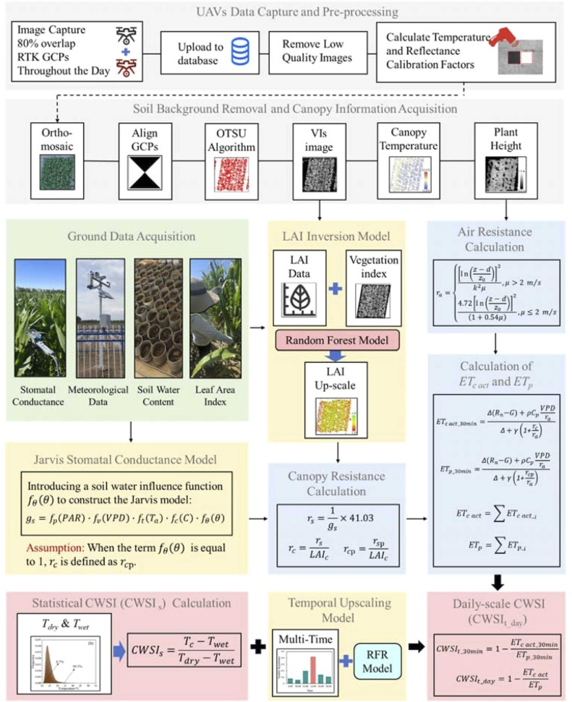
- Download: Download high-res image (1010KB)
- Download: Download full-size image
Fig. 4. Flowchart showing the experimental methodology. The gray, green, yellow, blue, and pink backgrounds represent UAV image processing, ground data collection, model construction, key computational steps, and calculation results, respectively. VIs, vegetation Indices；LAI, leaf area index; PAR, photosynthetically active radiation; VPD, vapor pressure deficit; T_{a}, Air Temperature; 𝜃, soil moisture content; 𝑔𝑠, stomatal conductance; r_{s}, stomatal resist_{a}nce; r_{a}, aerodynamic resistan_{c}e; r_{c}, canopy resistance; r_{cp}, potential canopy resistance; ET_{c act}, actual crop evapotranspiration; ET_{p}, potential crop evapotranspiration; CWSI_{s}, statistical CWSI; CWSI_{t_30min}, 30-minute-scale CWSI; CWSI_{t_day}, day-scale CWSI.
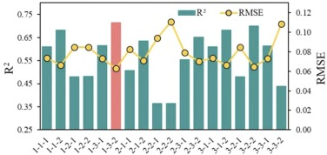
- Download: Download high-res image (105KB)
- Download: Download full-size image
Fig. 5. Different combinations of Jarvis model validation accuracy. 1–1–1 to 3–3–2 are different Jarvis model numbers, and R2 is the coefficient of determination and RMSE is the root mean square error.
3.1.2. LAI inversion model
Fig. 6a depicts the distribution characteristics of the measured maize LAI for the different irrigation treatments during the four growth stages. There was a significant increase in LAI during the vegetative growth stage (V9–VT), with the average LAI increasing from 2.99 to 4.21. At the VT stage, the average LAI for each experimental treatment maximized. During the reproductive growth stage, the variation of the average LAI was relatively small, showing a slight decreasing trend. The average LAI at the R1 stage was 3.82, and at the R3 stage, it was 3.67. Overall, the change trend aligns with the actual growth pattern of spring maize.
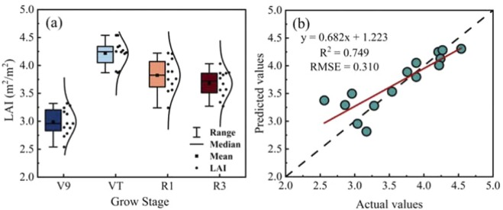
- Download: Download high-res image (177KB)
- Download: Download full-size image
Fig. 6. Statistics of measured LAI(a) and accuracy of LAI estimation model based on VI and RFR(b). V9, VT, R1, and R3 are the Ninth leaf stage, Tasseling stage, Silking stage, and Milk stage of maize, respectively.
The spectral information extracted from the multispectral images, including five original bands and six VIs, was inputted into the RFR model to estimate the maize LAI. The validation statistical results are shown in Fig. 6b, indicating that the LAI estimation model constructed using spectral information and the RFR model exhibited high accuracy, with an R² of 0.749 and an RMSE of only 0.310. Therefore, in this study, the LAI model was used to invert the maize LAI in the experimental area, serving as the basis for upscaling leaf stomatal conductance to canopy conductance.
3.1.3. Calculation of canopy resistance
The final Jarvis model for stomatal conductance, combined with the LAI inversion results from Eq. (27), was used to upscale leaf stomatal conductance to canopy conductance and calculate r_{c} for different irrigation treatments during various growth stages. The daily (R_{n} > 0) variations of r_{c} for each treatment during the four growth stages are plotted in Fig. 7. r_{c} exhibited a gradual increase in the morning and noon, followed by a sharp increase after 15:00. This trend was attributed to an afternoon rise in air temperature, increased VPD, and reduced soil surface water supply capacity owing to evaporation (Fig. 3). As sunset approaches, the solar elevation angle decreases, leading to a reduction in incident radiation. Consequently, the extinction coefficient of the canopy increases, resulting in fewer leaves receiving light. This reduction in light energy causes stomatal closure, leading to increased canopy resistance (Gutierrez and Meinzer, 1994). There were slight differences in the magnitude of r_{c} among different growth stages. During the V9 and R3 stages, r_{c} was greater than that during the VT and R1 stages. This is because during the V9 stage, the maize canopy had a lower LAI, resulting in higher r_{c}. Conversely, during the VT and R1 stages, maize leaf growth was vigorous, and LAI maximized, leading to a lower r_{c}. R3 corresponds to the late growth stage of maize, during which the canopy leaves senesce, leading to a decrease in 𝑔𝑠 and an increase in r_{c}.
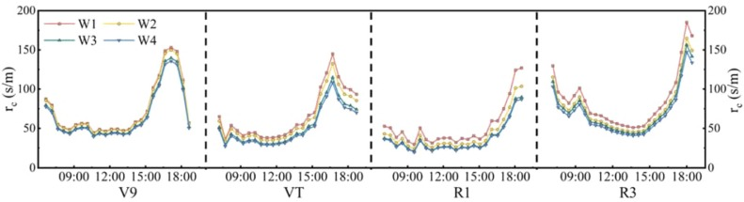
- Download: Download high-res image (180KB)
- Download: Download full-size image
Fig. 7. Daily variation of corn r_{c} at various stages of fertility. W1, W2, W3, and W4 represent high deficit, moderate deficit, slight deficit, and local irrigation, respectively. V9, VT, R1, and R3 are the Ninth leaf stage, Tasseling stage, Silking stage, and Milk stage of maize, respectively.
Looking at the different water control treatments across the four growth stages, r_{c} consistently followed the order of W1 > W2 > W3 > W4. The maize r_{c} increased continuously with decreasing irrigation water volume. This is because the roots struggled to extract sufficient water from dry soil to meet the carbon metabolism and assimilation needs of the plant, resulting in decreased leaf water potential and cell tension, thereby reducing 𝑔𝑠 (Liao et al., 2022). Consequently, r_{c} increased with decreasing irrigation water volume.
Overall, the r_{c} values of maize at different growth stages fluctuate significantly due to daily meteorological variations. Treatments experiencing water stress exhibit higher r_{c} values compared to those experiencing no water stress.
3.2. CWSI_{t_day}
3.2.1. Calculation of ET_{cact} and ET_{p}
Cloudy days can affect CWSI performance. Using the daily average CWSI on sunny days can reduce the environmental impact of the index (Osroosh et al., 2016). In this study, only the daytime conditions of the crops were considered. ET_{c act_30min} and ET_{p_30min} for each irrigation treatment during the four growth stages of maize were calculated using (6), (7), respectively. Cases in which R_{n} was greater than 0 were accumulated. The resulting ET_{c act} and ET_{p} for different growth stages and treatments are shown in Fig. 8. During the V9 stage, the crop was not fully developed, resulting in lower transpiration rates. There were no significant variations in either ET_{c act} or ET_{p} among the treatments. The average ET_{c act} for the four treatments was 6.46 mm d⁻¹, and the average ET_{p} was 9.12 mm d⁻¹. However, upon entering the VT stage, temperatures and therefore plant growth rates increased, leading to increased transpiration. The average ET_{c act} for the four treatments was 8.87 mm d⁻¹, and the average ET_{p} was 17.8 mm d⁻¹. Variations among treatments were evident, showing an increasing trend in ET_{c act} with increasing irrigation. However, no clear ET_{p} variation pattern was observed among the treatments. During the R1 stage, both ET_{p} and ET_{p} maximized, with an average ET_{c act} of 12.54 mm d⁻¹ and an average ET_{p} of 26.12 mm d⁻¹ across the four treatments. The differences in ET_{c act} among the treatments were maximized at this stage, as were the discrepancies between ET_{c act} and ET_{p} within each treatment. As maize grains gradually mature, plants tend to transfer more water to fruits, resulting in leaf senescence and reduced physiological activity. Consequently, the transpiration rate decreased during the R3 stage, with the average ET_{c act} across the four treatments decreasing to 7.06 mm d⁻¹ and the average ET_{p} decreasing to 16.33 mm d⁻¹. The differences in ET_{c act} among the different treatments also diminished during this period. In other words, except for the V9 stage, maize showed a trend of decreasing ET_{c act} with increasing levels of water stress.
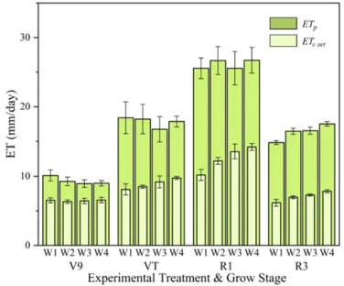
- Download: Download high-res image (158KB)
- Download: Download full-size image
Fig. 8. Changes in actual crop evapotranspiration (ET_{c act}) and potential crop evapotranspiration (ET_{p}) at different fertility treatment stages. W1, W2, W3, and W4 represent high deficit, moderate deficit, slight deficit, and local irrigation, respectively. V9, VT, R1, and R3 are the Ninth leaf stage, Tasseling stage, Silking stage, and Milk stage of maize, respectively.
3.2.2. Daily variation of the CWSI_{t_day}
The results of the CWSI_{t_30min} calculation were plotted statistically to obtain the daily variation of CWSI_{t_day} in each fertility period (Fig. 9). The CWSI_{t_30min} values of the four treatments in different fertility periods of maize produced similar trends, with lower values at sunrise in the early morning and a gradual increase over time. The CWSI_{t_30min} values before noon until sunset all fluctuated in a stable range.
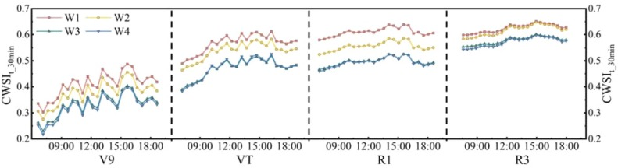
- Download: Download high-res image (190KB)
- Download: Download full-size image
Fig. 9. Daily changes in CWSI_{t_30min} at different fertility stages. CWSI_{t_30min} is the 30-minute-scale CWSI. W1, W2, W3, and W4 represent high deficit, moderate deficit, slight deficit, and local irrigation, respectively. V9, VT, R1, and R3 are the Ninth leaf stage, Tasseling stage, Silking stage, and Milk stage of maize, respectively.
From the perspective of the same growth stage, the daily variations of the CWSI_{t_30min} values of the different treatments exhibited consistent trends. This was because in the calculation of the CWSI_{t_30min}, the meteorological conditions during the same time periods were consistent among the treatments. However, because r_{c} and r_{cp} were determined for each treatment using the same Jarvis model for stomatal conductance, i.e., Eq. (30), the parameters primarily affecting the magnitude of the CWSI_{t_30min} for each treatment were LAI, 𝑓𝜃⁡(𝜃), and plant height. These parameters did not change on the same sampling day, resulting in similar trends in the daily variation of the CWSI_{t_30min} among the treatments, albeit with different magnitudes. Notably, the CWSI_{t_day} can effectively reflect the water conditions among different irrigation treatments, particularly during the VT and R1 stages. Here, significant differences were evident among the treatments, and they were pronounced at any given time during the day. There was no significant difference between treatments W3 and W4, with the daily variations of r_{c} being very similar (Fig. 7).
3.3. CWSI_{S}
Based on the results obtained using Eq. (3) for the six time intervals, we plotted the daily variation of the CWSI_{s} for the four growth stages (Fig. 10). The CWSI_{s} for different growth stages of each treatment exhibited an inverted “U” shape, with lower values in the morning and evening and higher values around noon. The CWSI_{s} maximized approximately 14:00, closely resembling the trend of T_{a}.
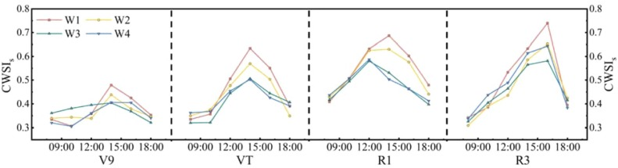
- Download: Download high-res image (175KB)
- Download: Download full-size image
Fig. 10. Daily variation of CWSI_{S} at different fertility stages. CWSI_{S} is statistical CWSI calculated from histogram of corn canopy temperature. W1, W2, W3, and W4 represent high deficit, moderate deficit, slight deficit, and local irrigation, respectively. V9, VT, R1, and R3 are the Ninth leaf stage, Tasseling stage, Silking stage, and Milk stage of maize, respectively.
In the VT and R1 growth stages, the CWSI_{s} exhibited an inversely proportional trend, decreasing with increasing irrigation amounts. This was especially pronounced in the afternoon. However, in the V9 and R3 stages, only the CWSI_{s} values for the severe water stress (W1) and moderate water stress (W2) treatments were significantly higher than the others at 14:00 and 16:00. This indicates that using the CWSI_{s} to monitor water stress in maize is most effective during the mid-growth stages when the plants are more vigorous, particularly in the afternoon when light intensity and temperatures are maximum.
3.4. Relationships of the CWSI_{t_day} and CWSI_{s} with g_{s}
𝑔𝑠 is an important indicator of plant water status (Ezenne et al., 2019). Therefore, in this study, we measured 𝑔𝑠 during daytime (8:00–18:00) under various irrigation treatments and used it as an indicator of maize water status to evaluate the CWSI_{t_day} and CWSI_{s}. Fig. 11 and Fig. 12 show the relationships between the two types of CWSI and 𝑔𝑠.
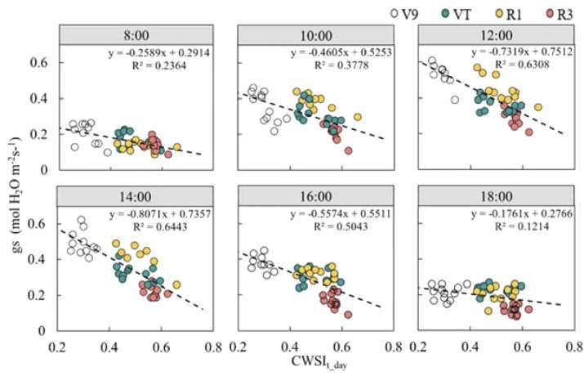
- Download: Download high-res image (327KB)
- Download: Download full-size image
Fig. 11. Relationships between measured stomatal conductance (𝑔𝑠) and daily scale CWSI (CWSI_{t_day}) acquired at 8:00, 10:00, 12:00, 14:00, 16:00, and 18:00. V9, VT, R1, and R3 are the Ninth leaf stage, Tasseling stage, Silking stage, and Milk stage of maize, respectively.
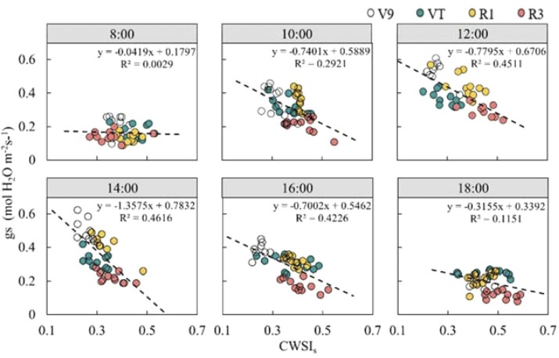
- Download: Download high-res image (323KB)
- Download: Download full-size image
Fig. 12. Relationships between measured stomatal conductance (𝑔𝑠) and statistical CWSI (CWSI_{s}) acquired at 8:00, 10:00, 12:00, 14:00, 16:00, and 18:00. V9, VT, R1, and R3 are the Ninth leaf stage, Tasseling stage, Silking stage, and Milk stage of maize, respectively.
We observed that the variation of 𝑔𝑠 was smaller in the morning compared to that at noon or in the afternoon. Specifically, the range of 𝑔𝑠 values (i.e., the difference between the highest and lowest 𝑔𝑠 values) measured at 8:00 was narrower than that measured at noon and in the afternoon. The distribution range of
The calculation results of the CWSI_{t_day} were used to generate high resolution CWSI distribution maps for the maize experimental fields at the four growth stages (Fig. 13). During the V9 stage, only a few plots in treatment W1 experienced mild water stress, whereas the other treatments did not. At the VT and R1 stages, some plots under treatments W1 and W2 experienced varying degrees of water stress. However, there was a difference between them, as indicated by the higher CWSI values for plots under treatment W1 than those under treatment W2. In R3, all the treatments exhibited relatively high CWSI values, suggesting different levels of water stress across all treatments. Nevertheless, this observation is inconsistent with actual conditions because of the misclassification of crop leaf senescence as water stress by the CWSI_{t_day}.
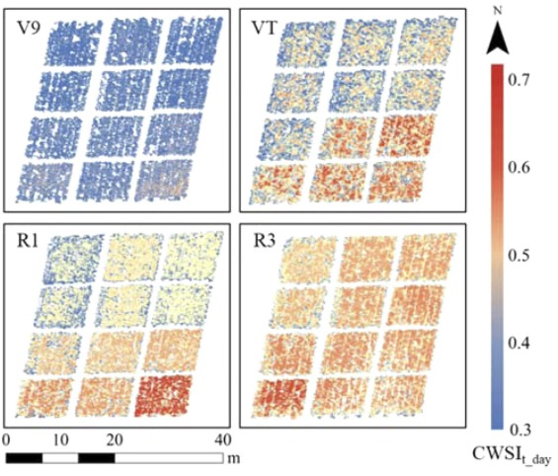
- Download: Download high-res image (472KB)
- Download: Download full-size image
Fig. 13. Distribution of daily scale CWSI (CWSI_{t_day}) at four fertility maize stages in the experimental area. V9, VT, R1, and R3 are the Ninth leaf stage, Tasseling stage, Silking stage, and Milk stage of maize, respectively.
3.5. Temporal upscaling model construction
Although the CWSI_{t_day} offers greater accuracy for monitoring crop water status than that of the CWSI_{s}, it still requires labor-intensive ground observations of various parameters, such as 𝑠 and 𝜃, and continuous climate monitoring. This section focuses on developing a temporal upscaling model from multiple observations of UAV thermal infrared data to achieve results comparable to those of the CWSI_{t_day}, thereby enhancing its practical applicability.
Different time observations of the CWSI_{s} were used as independent variables, whereas the CWSI_{t_day} was used as the dependent variable in the RFR algorithm for importance assessment. Fig. 14 displays the relative importance of the CWSI_{s} at different time periods. Evidently, the CWSI_{s} observed at 14:00 had the highest relative importance, reaching 0.42. The relative importance of the CWSI_{s} for the other time intervals followed the descending order of 12:00, 16:00, 18:00, 8:00, and 10:00, with relative importance values of 0.20, 0.14, 0.11, 0.08, and 0.06, respectively.
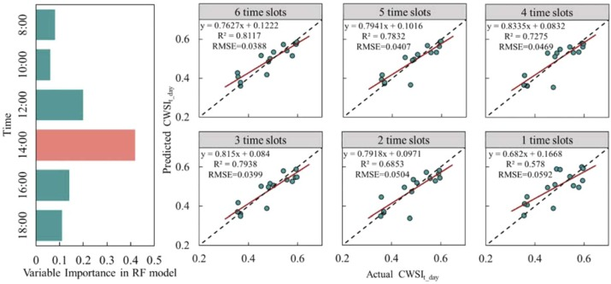
- Download: Download high-res image (272KB)
- Download: Download full-size image
Fig. 14. The importance of statistical CWSI (CWSI_{s}) prediction of daily scale CWSI (CWSI_{t_day}) at different time periods in RF model and the prediction accuracy of CWSI_{t_day} with multi-time combination. 1 time slots to 6 time slots represent the CWSIs combinations of different time periods in order of importance.
The training and testing datasets were split at a ratio of 7:3. The RFR models were constructed by sequentially inputting datasets sorted by importance. Fig. 14 indicates that the model built using full-day observations from all six time slot intervals achieved the highest predictive accuracy, with an R² of 0.81 and RMSE of 0.039. Models built solely on the datasets from 12:00, 14:00, and 16:00 outperformed those using data from five time slots, with an R² of 0.79 and RMSE of 0.04. This marginal difference in accuracy with respect to full-day observations suggests that observations from noon to early afternoon can substitute full-day observations with similar effectiveness, thereby enhancing the cost-effectiveness of CWSI_{t_day} observations.
4. Discussion
In this study, the CWSI_{t}__{day} was computed based on energy balance principles and the Penman–Monteith equation. This method considers several key meteorological factors that influence canopy energy balance, such as R_{n}, u, VPD, r_{a}, and r_{cp}, while also considering the diurnal variations of these meteorological factors over time. Jackson et al. (1981) calculated the CWSI_{t} using the energy balance equation, with ET_{p} assumed to be equal to the water surface evaporation. Therefore, r_{cp} was considered fixed. However, in reality, r_{cp} may vary during the day depending on the crop evapotranspiration demand or climatic variables, rather than being a fixed value. Assuming r_{cp} as a fixed value can lead to errors when representing the crop water status using the CWSI_{t} (Gonzalez-Dugo et al., 2020). In this study, r_{cp} was estimated using the Jarvis model, in which the effect of climate change on r_{cp} during the day was fully considered, which is the main reason why different irrigation treatments showed different ET_{p} values during the same fertility period (Fig. 8). Inaccurate estimation of r_{a} can lead to insignificant differences in the CWSI_{t} obtained under both well-watered and water-stressed conditions (Han et al., 2018). In farmland environments, if the estimated r_{a} is small, wind can easily pass through the fields, carrying away moisture from the vegetation surface, promoting evaporation, and directly influencing the CWSI. The development of UAVs provides a new method for large-scale monitoring of crop canopy height (Oehme et al., 2022). In this study, by combining UAV-derived DSM data, plant height was calculated while considering the differences in plant height owing to varying levels of water stress across different irrigation treatments as the maize growth stage progressed, thereby enhancing the accuracy of r_{a} estimation. However, conducting r_{a} observations once per growth stage seems inadequate. Averaging r_{a} over a season reduces the uncertainty in predicting crop water stress at different growth stages (Han et al., 2018, Katimbo et al., 2022). Therefore, increasing the frequency of r_{a} observations at each growth stage and using seasonal average r_{a} are worth considering for future improvements.
In our analysis of the diurnal variation of the CWSI_{t}__{day} (Fig. 9), we found that ET_{c act}/ET_{p} was not constant during the day, indicating that the CWSI_{t}__{day} fluctuated throughout the day. The CWSI_{t}__{day} appeared to be low in the early morning, then gradually increasing until noon, trending towards a stable fluctuation, and continuing until sunset. This pattern is similar to that observed by Antoniuk et al. (2021) in wheat experiments, in which ET_{c act}/ET_{p} was low in the morning and high around noon. This occurs because crops transpire at a near-potential transpiration rate for a short period of time in the early morning. They replenish water during nighttime and use the stored water in plant tissues for transpiration in the morning (Peng et al., 2023). In this study, this resulted in ET_{c act} approaching ET_{p}, leading to decreased ET_{c act}/ET_{p} and CWSI_{t_day}. However, as time progressed, the difference between transpiration and root water uptake increased, causing the transpiration rates to deviate from the potential rates, and this near-potential transpiration ceased rapidly. Despite this, the diurnal variation of the CWSI_{t}__{day} was still substantially more stable than that of the CWSI_{s}. The range of variation (i.e., difference between the maximum and minimum values) of the CWSI_{t}__{day} within the same treatment during the day was relatively small. Taking the example of the W1 growth stage (Fig. 9), the variation of the CWSI_{t}__{day} values was the most pronounced during the V9 stage, reaching a range of 0.13. Meanwhile, during the VT, R1, and R3 stages, the values were only 0.09, 0.03, and 0.03, respectively. This stability is considerable compared to the diurnal variations of the CWSI values in our study and other studies, which typically range from 0.5 to 0.8 (Agam et al., 2013, da Silva and Rao, 2005, Liu et al., 2023).
Regarding the trends of daily variations of r_{c} (Fig. 7), CWSI_{t}__{day} (Fig. 9), and CWSI_{s} (Fig. 10), treatments W3 (80 % of conventional irrigation) and W4 (100 % of conventional irrigation) showed similar trends and magnitudes throughout the day. This could be attributed to the slight water deficit in treatment W3, which enhanced the ability of the maize root systems to absorb water from the soil in the root zone, thereby meeting the demands of growth and physiological activities (Chai et al., 2016). However, in this study, 80 % conventional irrigation cannot be recommended as the optimal irrigation amount, because it remains unclear whether it would impact maize yield during the maturation period. This indicates that at the V9 stage, none of the plots, including the severely water-stressed W1 treatment, experienced significant water stress. This is due to a heavy irrigation event in the Hetao irrigation district during the autumn of the previous year, which resulted in favorable soil moisture conditions during the early growth stages of maize. The water stress treatments in our experimental design were unable to significantly affect soil moisture conditions in the short term, leading to the lower CWSI values observed at the V9 stage. Soil moisture conditions for the V9 stage are presented in Appendix A.
Compared to other growth stages, the CWSI_{t}__{day} values of various irrigation treatments during the R3 stage were higher and more consistent. This is because treatments with sufficient water supply during the R3 stage advance into the maturity phase earlier, leading to reduced leaf physiological activity, decreased 𝑔𝑠, and lower ET_{c act}/ET_{p} (Fig. 8), resulting in higher CWSI_{t}__{day} values approaching those of the water-stressed treatments. In the daily variation of the CWSI_{s} during the R3 stage (Fig. 10), we observed an increase of the CWSI_{s} values for treatments W3 and W4 under better irrigation conditions. This indicates that the CWSI_{s} suffers from the same issue as that of the CWSI_{t}__{day}, namely, misinterpreting leaf senescence during the maturation phase as crop water stress. Therefore, neither the CWSI_{t}__{day} nor the CWSI_{s} are suitable for diagnosing crop water stress during the late stages of maize growth. This is because they are both physiological indicators based on leaf responses. Plants in the late stages may not represent the entire canopy conditions (Moeller et al., 2007). During this period, leaves are in a senescent state with reduced physiological activity. Water transport in crops is more focused on fruit development, exhibiting different physiological responses compared to those in other growth stages. Misdiagnosis of the CWSI during this period may affect proper irrigation practices, thereby affecting the crop yield.
Rud et al. (2014) found in their potato irrigation experiment that statistical CWSI values were lower than the empirical and theoretical CWSI values, particularly for well-irrigated treatments. However, in this study, no significant differences were observed between the CWSI_{t}__{day} and CWSI_{s}. This may be because the experimental design encompassed both well-irrigated (W4) and severely water-stressed (W1) conditions, allowing for an accurate estimation of T_{wet} and T_{dry} through statistical calculations. Nevertheless, this simplified approach may not be universally applicable (Rud et al., 2014). This is especially the case in areas where both water-stressed and well-irrigated conditions may not be adequately represented, leading to potentially erroneous estimations of T_{wet} and T_{dry}. Therefore, the application of the CWSI_{s} should be prioritized in large-scale agricultural fields with complex irrigation conditions to ensure that both water-stressed and well-irrigated scenarios are adequately represented. This limitation in application is similar to that of the Temperature Vegetation Dryness Index (TVDI)(Sandholt et al., 2002), which requires the study area to include land types ranging from bare soil to fully vegetated cover. In contrast, CWSI is based on surface energy balance principles, with a clear physical basis, and does not require the inclusion of all land cover types within the study area. These factors make CWSI superior to TVDI(Yang et al., 2010). Additionally, the high-resolution images provided by UAVs can effectively separate soil from vegetation, further enhancing the accuracy of CWSI in diagnosing water stress in vegetation alone, providing a stronger foundation for its application. That said, variations in climatic conditions can still significantly affect canopy temperature, which is used to calculate instantaneous CWSI and TVDI, introducing uncertainty in their results(Bai et al., 2017).
However, the ease of data acquisition allows the possibility of using UAVs to obtain the CWSI_{s} multiple times a day. Using the RFR model to combine CWSI_{s} observations taken at 12:00, 14:00, and 16:00 to build a temporal upscaling model can effectively replace the daily observations of the CWSI_{t_day}. This may be because meteorological conditions are relatively stable around noon, and using UAV thermal infrared measurements of canopy temperature during this time of day may help reduce the variability of the meteorological conditions (Stockle and Dugas, 1992). Midday and early afternoon are the hottest times of the day, during which crop transpiration rates are relatively high, leading to noticeable differences in physiological parameters under varying water conditions. Notably, crops often close their stomata during these times to reduce transpiration and minimize water loss, a phenomenon resembling “midday nap.” This reduces the cooling effect of transpiration(Koyama and Takemoto, 2014; Yadav et al., 2024). Additionally, leaf curling occurs, which decreases the leaf-air contact area and further lowers transpiration rates. These self-regulating mechanisms in plants lead to an increase in canopy temperature(Jones, 1992), resulting in a higher CWSI. It is also worth noting that water-stressed plants exhibit these effects earlier than well-watered plants (Bellvert et al., 2014).The study also found that the peak net radiation (R_{n}) occurs around 14:00 in the afternoon (Fig.3). A lower solar angle in the morning or later in the afternoon may lead to obstructed leaf coverage, potentially affecting the accuracy of the CWSI (Bellvert et al., 2014, Liu et al., 2020). Combining CWSI_{s} to develop a temporal upscaling model can effectively reduce the measurement workload. However, the model's transferability to various application scenarios must be tested in future research across different contexts.
Nevertheless, the evaluation of the responsiveness of both the CWSIs to crop water stress based on only six periods of 𝑔𝑠 seems to be insufficient. Future research should consider multiple indicators, such as soil moisture and plant stem/leaf water potential, and should not be limited to small-plot experiments. Instead, it should focus on diagnosing water stress in large-scale scenarios.
5. Conclusions
This study has demonstrated that the theoretically based daily-scale CWSI (CWSI_{t_day}) is an effective tool for monitoring maize water stress. The correlation between the CWSI_{t_day} obtained from the UAV data at the four growth stages and measured 𝑔𝑠 was higher than that between the CWSI_{s} and measured 𝑔𝑠. The CWSI_{t_day} exhibited smaller fluctuations throughout the day than the CWSI_{s}. The four periods of variation for V9, VT, R1, and R3 were 0.13, 0.09, 0.03, and 0.03, respectively, indicating greater stability and better temporal representativeness. We also found that the temporal upscaling model developed using CWSI_{s} observations at 12:00, 14:00, and 16:00 can effectively replace daily CWSI_{t_day} observations. The model achieved R² and RMSE values of 0.794 and 0.04, respectively, indicating that the replacement observations are cost-effective. Both the CWSI_{t_day} and CWSI_{s} incorrectly identified the reduced physiological activity of maize leaves owing to senescence at the end of the growth stage as water stress. Therefore, these indices are not suitable for diagnosing crop water stress during the late maize growth stages. This study proposes a new method for enhancing the accuracy of crop water stress diagnosis at the field scale by using a UAV platform to obtain a CWSI with high temporal (continuous) and spatial resolution.
CRediT authorship contribution statement
Dongliang Zhang: Resources, Funding acquisition. Jiang Bian: Software, Conceptualization. Yanying Bai: Software, Investigation. Xiaolong Hu: Writing – review & editing, Methodology. Yixuan Yang: Investigation, Data curation. Wei Yang: Supervision, Formal analysis. Zhongyi Qu: Writing – review & editing, Supervision, Resources, Funding acquisition. Qi Liu: Writing – review & editing, Writing – original draft, Supervision, Software, Resources, Investigation, Conceptualization. Liangsheng Shi: Writing – review & editing, Methodology, Conceptualization.
Declaration of Competing Interest
The authors declare that they have no known competing financial interests or personal relationships that could have appeared to influence the work reported in this paper.
Acknowledgments
This study was supported by two National Key Research and Development Programmes (No. 2021YFC3201205, No. 2021YFD1900605-08), a KEJIXINGMENG Project (No. 2021EEDSCXSFQZD011), and two Projects of Young Scientific and Technological Talents in Colleges and Universities of Inner Mongolia Autonomous Region (No. NJYT22045, No. NJYT23102).

